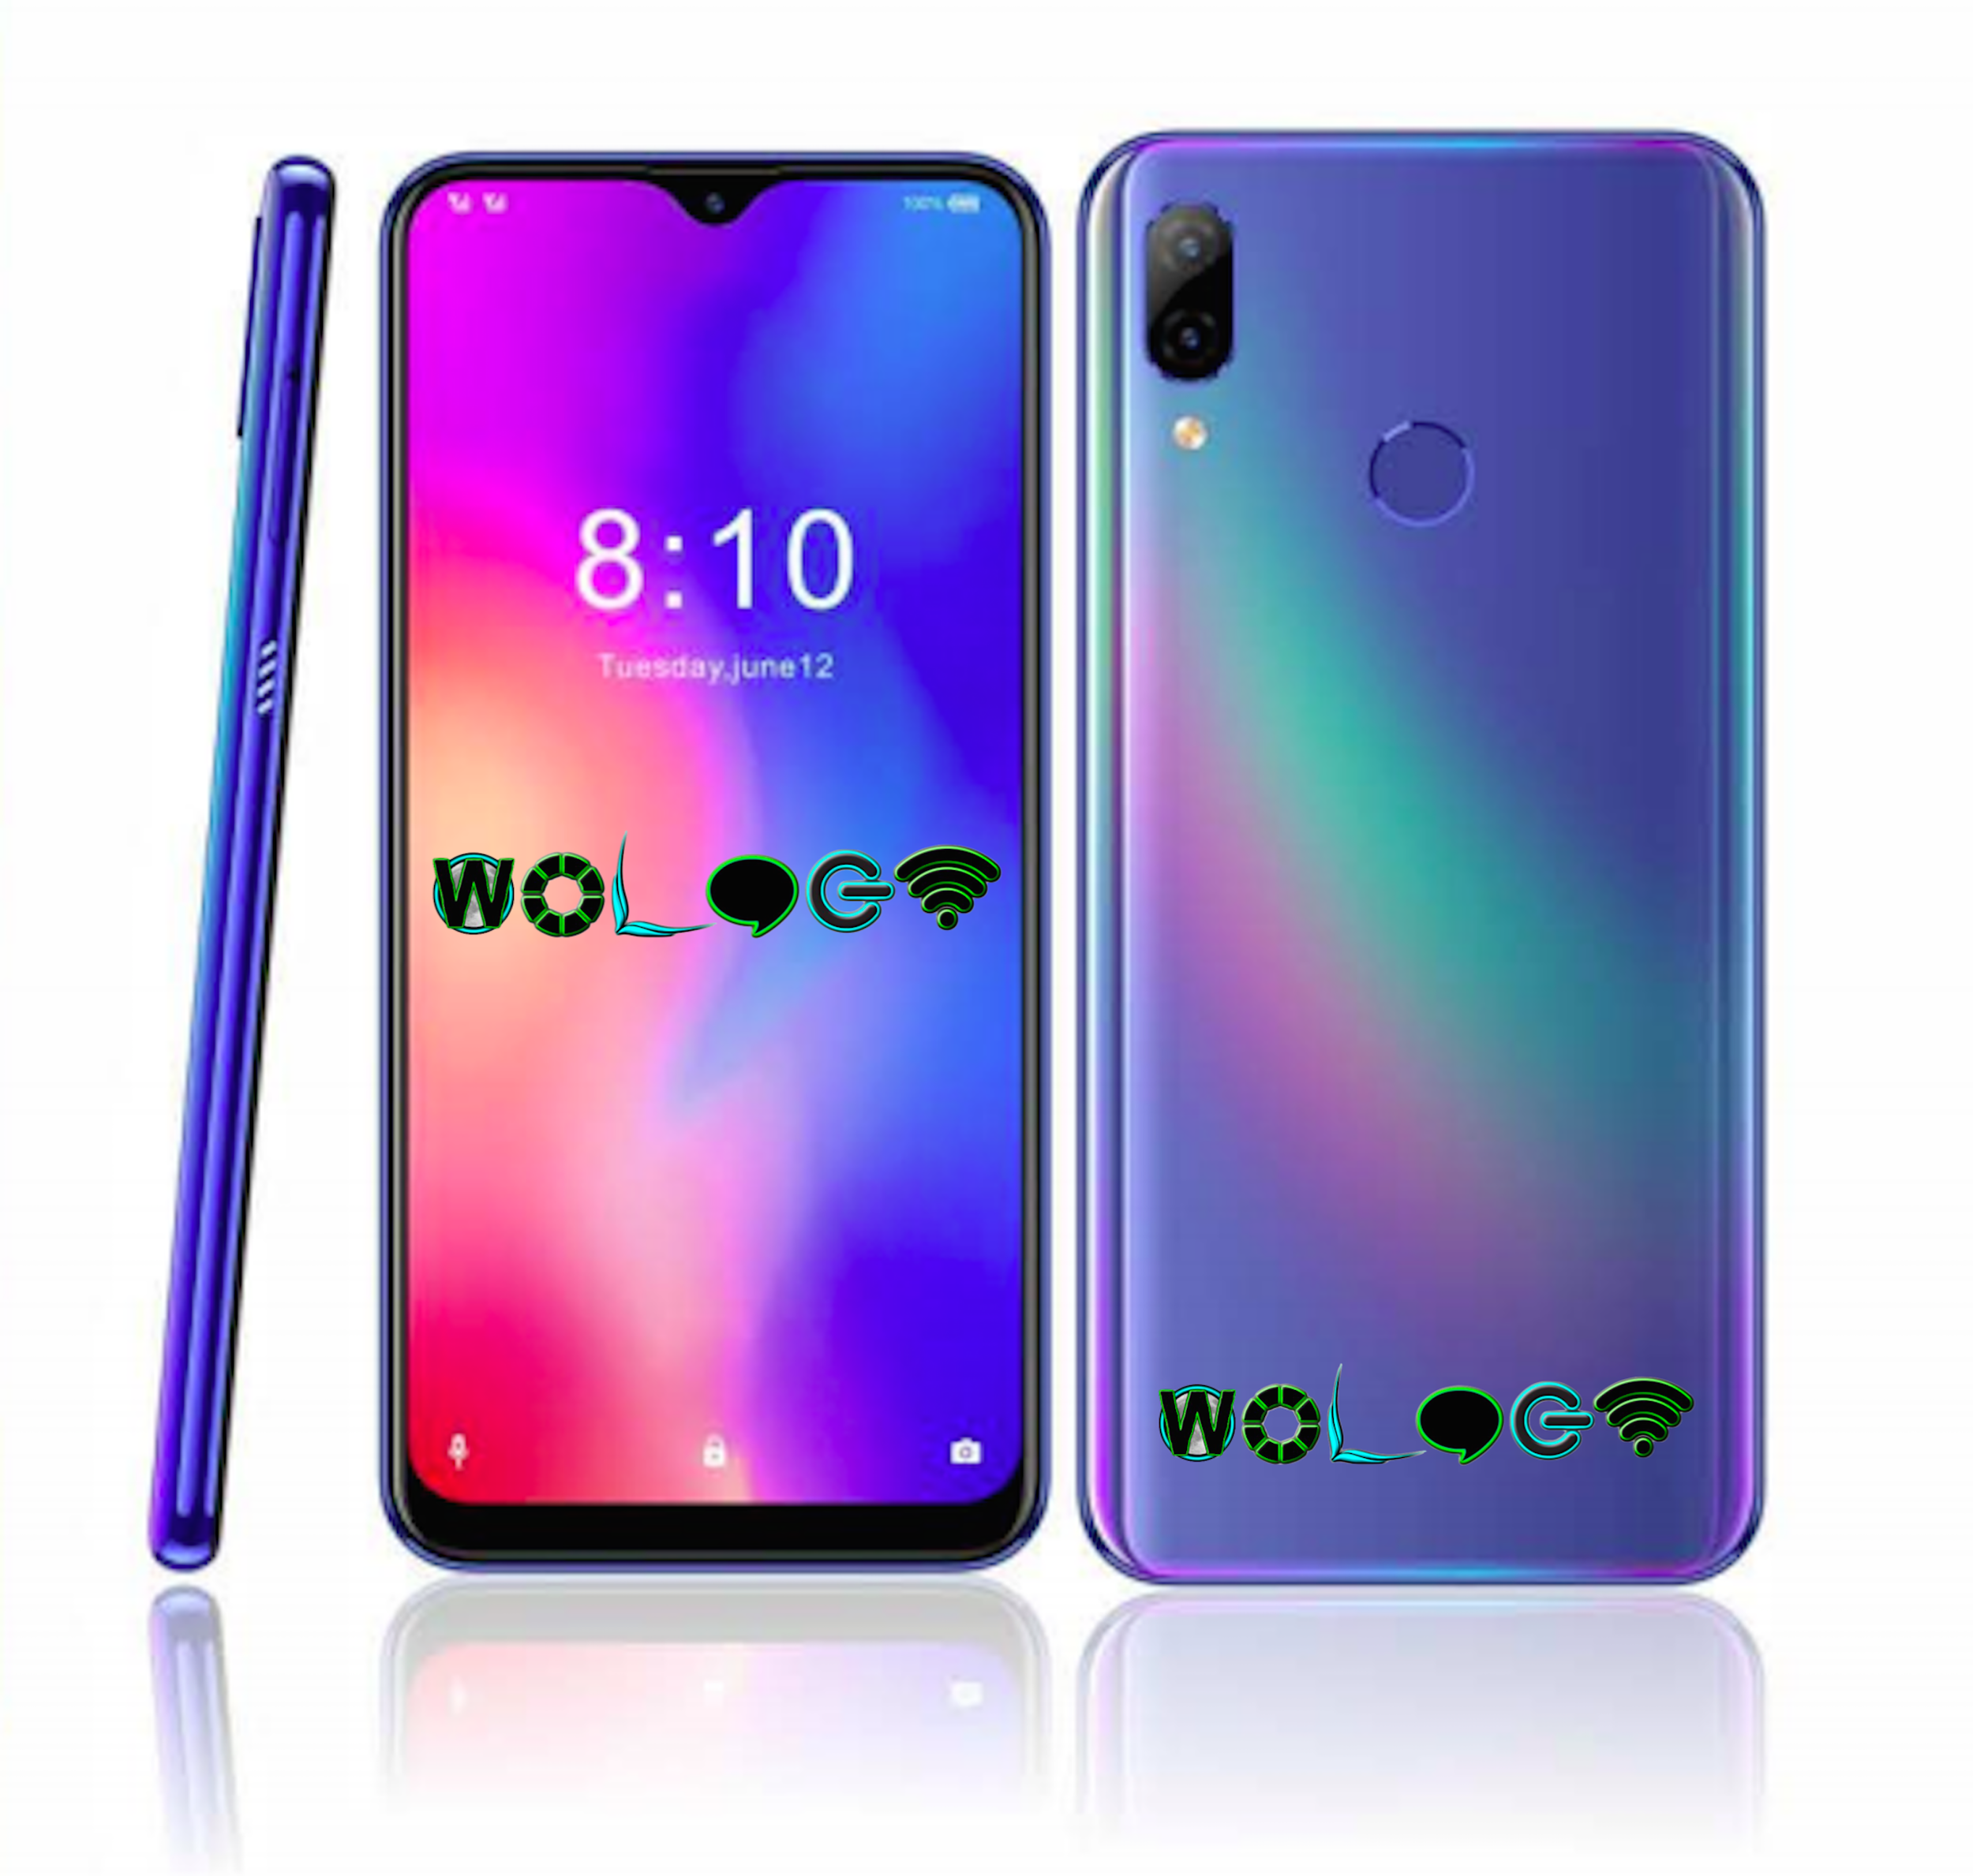

6.3 inch Octa core 4G Phone
Model Name: | Sha 1 aka Sha Phone
Price USD (FOB) | MOQ (pcs) | Price (USD)
 | 3-6K | $282
 | 7-10K + | $270
Tech Specifications
Display Screen | 6.3 inch FHD+ TFT LCD
Touch Screen | WaterDrop / Notch
Resolution | 1080x2340 Pixels 18:9
CPU | MTK6763 Octa Core @2.0GHz
RAM | 6GB
ROM (NAND FLASH) | 128GB
Operation System | Android 9.0
Network | WIFI | Yes, 802.11 b/g/n
 | GSM | B2 / 3 / 5 / 8
 | WCDMA | B1 / 2 / 5 / 8
 | 4G | TDD-LTE: | B40 / 41
 |  | FDD-LTE: | B2 / 4 / 5 / 7 / 12 / 17
 | Sensor | Compass + G-sensor + Light-sensor + Proximity sensor + Gyro + Magnet sensor
Special Functions | GPS | Yes
 | Bluetooth | Yes,Bluetooth 4.2
 | Fingerprint Unlock | FingerPrint Unlock
 | NFC | Yes
 | Wireless Charging | Yes, support
 | Pressure Sensing | Yes, support
Camera | 8.0MP Front camera / Rear Dual 16MP PDAF+0.3MP, AF with flash LED
Extend Port | 1.USB Interface | USB Type C
 | 2. Memory Card Slot | Micro SD card ( T-FLASH card), max 64GB
 | 3. OTG | Support
 | 4. Sound Effect | 3.5mm earphone socket
 |  | Built-in Microphone: Support, high sensitive input
Power Supply | Battery | 3900mAh
 | Adapter | Input:AC100-240V.50-60HZ, Output: 9V 2A fast charging type C
Working Time | 18 hours talk time;Standby time 400 hours
Language | Multi-Languages
Unit Size | 157.7*74.5*8.5mm
Supported Formats | Picture | JPEG, JPG, BMP, GIF etc...
 | Audio | MP4/MP3/WMA/APE/FLAC/AAC/WAV etc...
 | Video | AVI,WMA,3GP/MP4,MOV,MPG,VOB,MKV,FLV,TS/TP RMVB etc...
 | E-Book | UMD, TXT, PDF etc
 | Extras | Pre-Installed App
Accessories | User Manual, Adapter , Type C cable, Earphone
Packaging Information
Export Carton | 1. 24 Units Per Carton  2. Gift box Size:167*95*42mm  3. Master Carton:351X204X290mm  4. Weight:NW: KGS,G.W: KGS  5. 20" FCL/40"FCL/40"HQ:1200 / 2700 / 3400 Cartons  6. 20" FCL/40"FCL/40"HQ:28800 / 64800 / 81600 PCS
Certificates | CE/Rohs/FCC/GMS Certificates are available
Payment Terms | Full Payment must be received Prior to shipment
MOQ | 3000 PCS
Lead Time | Sample 5~7Days, Orders: About 45 days for 5K-10K after receiving deposit, if need GMS, 80 days for the first order
Remarks | No returns, No refunds, No credit lines, No exchanges, No chargebacks
 | Manufacturer's warranty: 1 Year
 | Price is FOB. Freight extra. Freight not included. Freight must be paid for prior to shipment. Please request a freight quote by visiting www.wiyne.com/products
 | Price is only valid for 30 days

