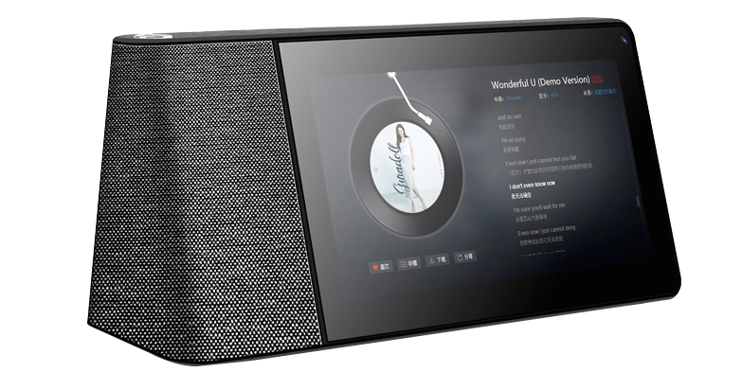

Model | WiYnEa Touch
Quantity  Prices | USD (FOB) | MOQ (pcs) | Price (USD)
 |  | 1000+ | $275
 |  | 5K | $272.50
 |  | 10K + | $270
Tech Specifications
Product Characteristic | Touchscreen AI Speaker
Type | Details | Descriptions
LCD | Screen Size | 7”
 | Screen Resolution | 1280*800
TP | Touch Module | Capacitive 5 points touch(G+P)
Battery | Capacity | 3000Mah
System Hardware Configuration
Type | Details | Descriptions
CPU | Type | MT8167A Quad-core ARM Cortex-A35
 | Speed | 1.5GHz
GPU | Type | IMG PowerVR GE8300
RAM | Capacity | DDR3 1G
ROM Flash | Capacity | Flash 6GB
5 Functions | Video
 | Music
 | Photo Album
 | Smart Home
5 Functions | Voice Interaction
Network Connections
Type | Details | Descriptions
WiFi | WiFi Module | WiFi 802 11b/g/n
Interface Configurations
Type | Details | Descriptions
USB interface | OTG/Data/Charging supportive | micro USB Port
Memory card socket | External memory | TF Card
Audio interface | 3.5
Necessary Accessories
Type | Details | Descriptions
Power Adapter | Standard Configuration | 5V/2A
USB data cable | Standard Configuration | Connect to PC
Giftbox | Standard Configuration | Gift Box
User Manual | Standard Configuration | User Manual
Software Configuration
Type | Details | Descriptions
Operating System | Operating System Version | Android 9.0
 | Manufacturer's Warranty Time | 12 Month
 | Delivery / Production  Time | About 45 days
Capabilities | Language | Multi-Languages, 20 + Countries
 | Video | MPG.MP4,MOV,FLV,MEG
 | Audio | MP3, WAV, MP4
 | Photo | JPG, JPEG, GIF, BMP, PNG
Accessories | User Manual, Charger Adapter
Packaging Information
 | Export Pallets | 1.480 Units Per Pallet  2. 20ft FCL - 10 pallets with 1*1.2*1.5 size  3. 40ft FCL - 20 pallets with 1*1.2*1.5 size
 | Certificates | CE/Rohs/FCC Certificates are available upon request
 | Payment Terms | Full Payment must be received Prior to shipment
 | MOQ | 1000 PCS
 | Remarks | No returns, No refunds, No credit lines, No exchanges, No chargebacks
 |  | Price is FOB. Freight extra. Freight not included. Freight must be paid for prior to shipment. Please request a freight quote by visiting www.wiyne.com/products
 |  | Price is only valid for 30 days

